 WESTERN SYDNEY COMMUNITY LIBRARY

*Nothing is pleasanter than exploring a lIbrary.*

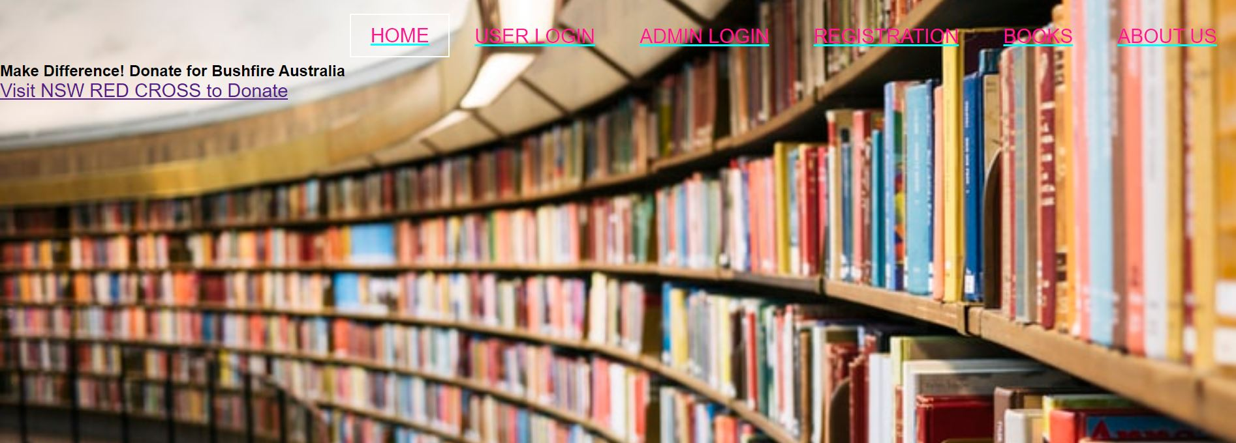

Western sydney Library is not only the library for students but also for the people living around the ST MARYS suburb of New South Wales. Library provides the academic books for the students and other miscellaneous books for the other users.Various local seminars, workshops, and events are notified on the home page. It also helps to support the social cause and natural disasters by encouraging users to raise funds or donate, providing the links on the home page.

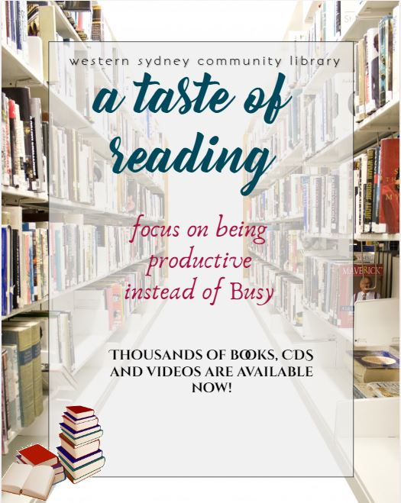 

|  |
| --- |
| RESPONSIVE WEB DESIGN  USE OF HTML,CSS AND JAVASCRIPTS  PHPMYADMIN AS THE DATABASE  BOOTSTRAPS |

